Shawano County Extension Local Government Resource Page
http://shawano.uwex.edu/community-development/local-government-resources/

Shawano County Extension Tribal Government Resource Page
http://shawano.uwex.edu/community-development/tribal-government-resources/

UW-Extension Local Government Center Publications (free)
http://lgc.uwex.edu/publications/publs.html

Other Useful Web Links Related to Local Government
http://lgc.uwex.edu/Weblinks.html

County Government: History, Services and Funding
https://www.wicounties.org/uploads/pub/county-government-2014-final.pdf

4th Edition, Wisconsin County Officials Handbook
https://www.wicounties.org/uploads/pub/4th-edition-handbook.pdf

Recommended Books:

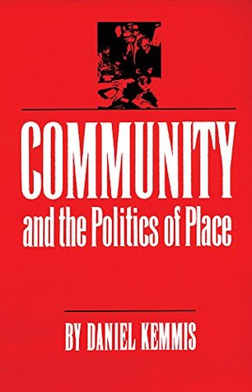

http://www.goodreads.com/book/show/577330.Community_and_the_Politics_of_Place

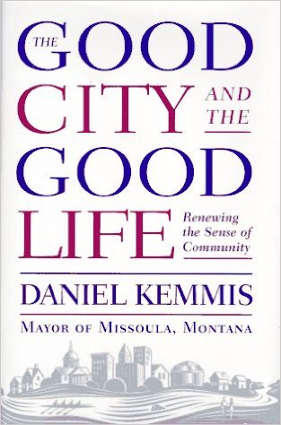

http://www.amazon.com/Be-Politician-Stimson-Bullitt/dp/0963163035/ref=sr_1_1?s=books&ie=UTF8&qid=1446829548&sr=1-1&keywords=to+be+a+politician+bullitt

And, an oldy but a goody, which may be still applicable to local government

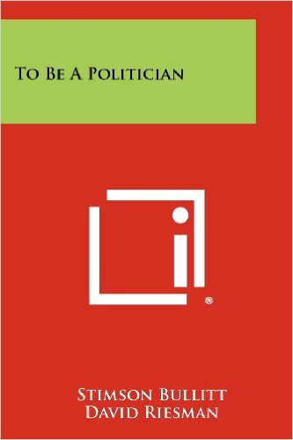

http://www.amazon.com/To-Be-Politician-Stimson-Bullitt/dp/1258381850

